EXPERIMENT 8

8.1.1//Multiplication of Two Square Matrices
Ans: ALGORITHM:
Step 1: Start
Step 2: Read dimension x
Step 3: Display "First Matrix"
Step 4: Initialize matrix M
Step 5: Read elements of matrix M
Step 6: Display "Second Matrix"
Step 7: Initialize matrix N
Step 8: Read elements of matrix N
Step 9: Initialize result matrix L with 0
Step 10: Set i = 0
Step 11: Repeat Steps 12 to 18 while i < x
Step 12: Set j = 0
Step 13: Repeat Steps 14 to 17 while j < x
Step 14: Set k = 0
Step 15: Repeat while k < x
L[i][j] = L[i][j] + M[i][k] * N[k][j]
k = k + 1
Step 16: Set j = j + 1
Step 17: Continue loop
Step 18: Set i = i + 1
Step 19: Print Result Matrix L
Step 20: Stop
FLOWCHART
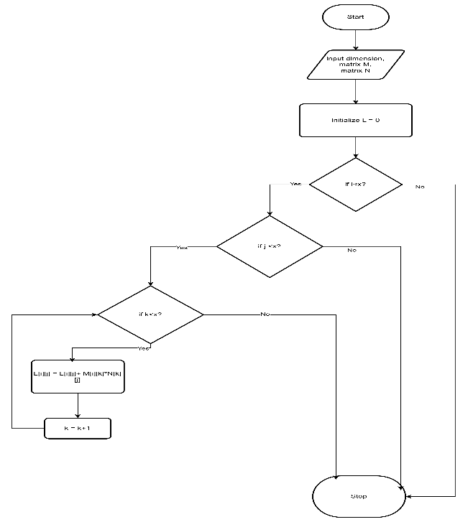
CODETANTRA:
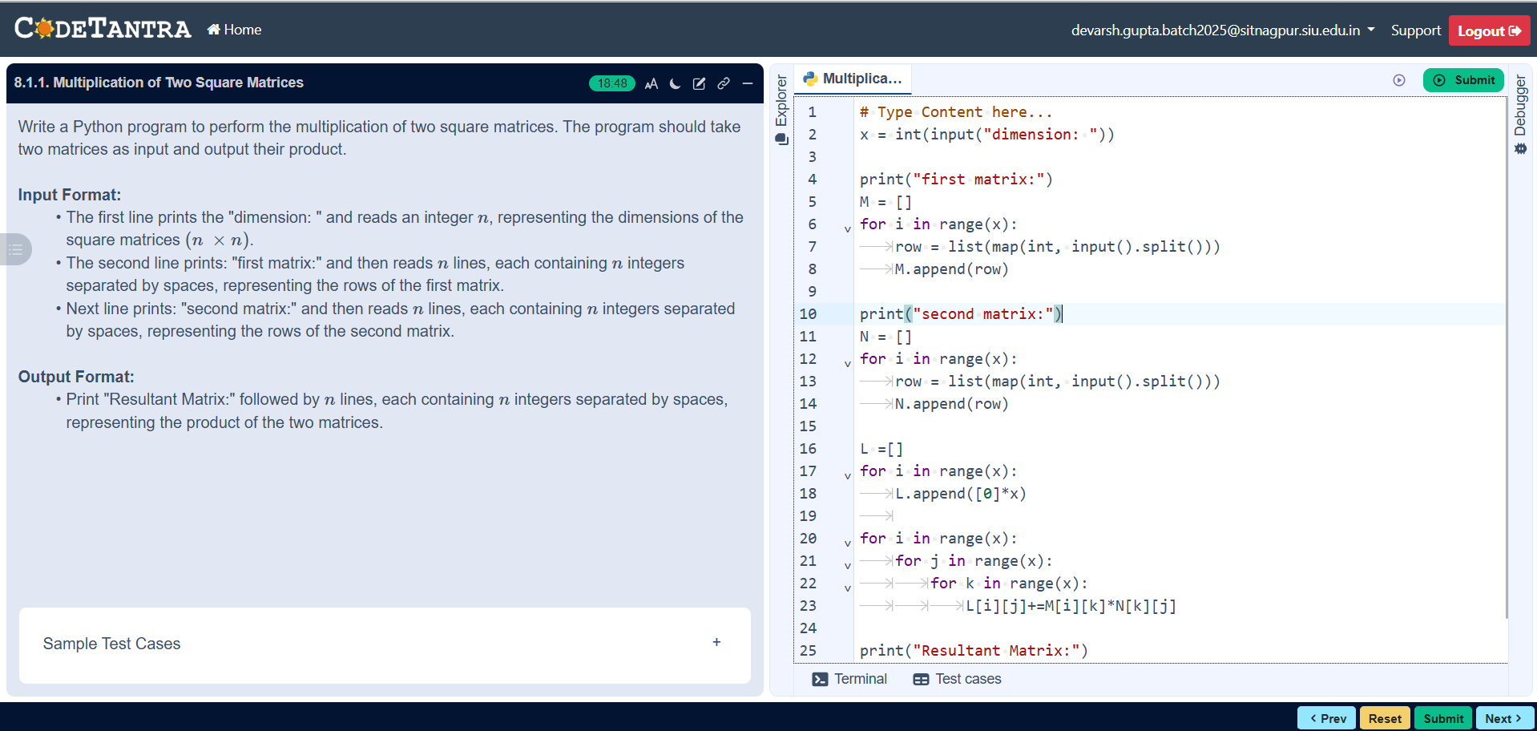
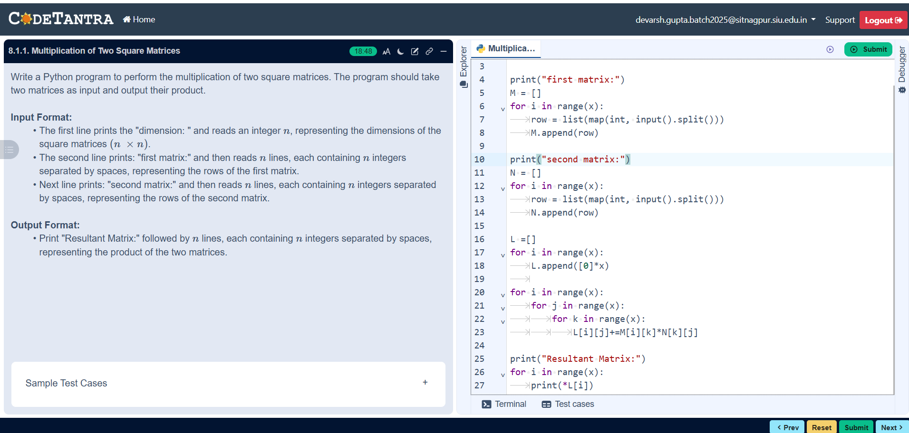
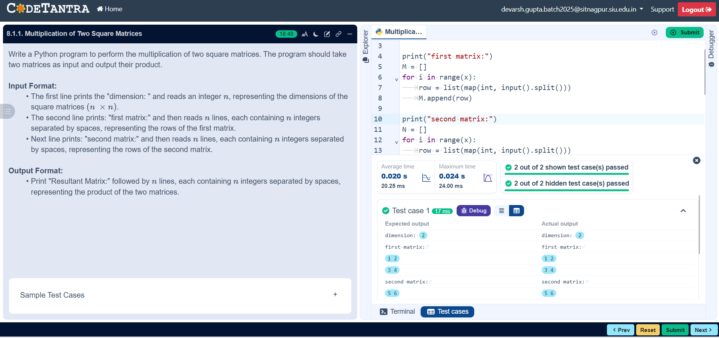

8.1.2//Prime number in a given range
Ans:ALGORITHM:
Step 1: Start
Step 2: Read begin
Step 3: Read end
Step 4: Set found = False
Step 5: Set num = begin
Step 6: Repeat while num ≤ end
Step 7: If num > 1 then
Step 8: Set flag = True
Step 9: Set i = 2
Step 10: Repeat while i < num
If num % i == 0 then
Set flag = False and Exit loop
Else
Set i = i + 1
Step 11: If flag == True then
Print num
Set found = True
Step 12: Set num = num + 1
Step 13: Repeat loop
Step 14: If found == False then
Print "No primes"
Step 15: Stop
FLOWCHART:

CODETANTRA:
